Memorandum

|  |  |
| --- | --- |
| To: | Luke Rogers - Coordinator Sustainability and Environment |
| From: | Dr Ryan Vogwill - Director and Principal Hydrogeologist |
| cc: | Mike Whitehead - Aquatic Ecologist |
| Date: | 7/9/2023 |
| Re: | Lake Richmond - Existing data sufficiency for assessing thrombolite management options. |

**Disclaimer**

"The authors do not make any warranty, guarantee or representation in this report document and/or any subject therein. The reader should evaluate and form their own view pursuant to this report document and will hold the authors harmless without limitations. The writer does not enter into any contract with the reader pursuant to this report, without limitations."

**Introduction**

As part managing impacts to Lake Richmond and assessing the management options for recovery of the thrombolite community the City of Rockingham has requested review of their recent and existing data collection. The focus of this review was to assess and advise on the following:

1. Whether the data outlined in these reports will assist in informing management actions for Lake Richmond or if there are any key water quality data gaps that still need to be investigated;
2. What additional studies or investigations (if any) would be required to:
   1. Understand the impacts of stormwater inflow into Lake Richmond, and
   2. Inform (with a high degree of confidence) the predicted benefits of available management/ intervention measures.
3. Any other comments or recommendations that you think would support the project.

An initial high-level summary of the review is provided followed by a dataset compilation table (Table 1), specific points raised during the review of individual documents and finally answers to the questions posed above.

**Summary**

The data collected by various groups and for various projects, as shown in Table 1, has utility in assessing the management feasibility of recovering Lake Richmond’s thrombolites but the lack of a targeted temporally and spatially consistent monitoring regime reduces this utility. The reports provided (and reviewed) are fairly generic and simplistic, with most only providing the data with minimal hydroecological interpretation and no interpretation focused on key thrombolite formation processes. Regular ongoing monitoring (approximately monthly) of surface water levels/chemistry and groundwater levels/chemistry would have been preferable but the existing data set should be consolidated and an initial attempt to model management intervention is now warranted. An ongoing monitoring regime should be developed and implemented but the monitoring regimes proposed in the reports fall short of this in the context of thrombolite hydroecology.

**Table 1 - Existing hydrological data summary.**

| **Project** | **WL data point** | **WL data continuous** | **WQ data point** | **WQ data continuous** | **Comments** |
| --- | --- | --- | --- | --- | --- |
| 360 Environmental 2022 | Nil | Nil | 5 physical parameters (temp, EC, pH, REDOX and DO) 13 major anions and cations) every 6 weeks. Total of 9 readings in GW only. | EC, salinity, temp, TDS Oct 21 to August 22 at 9 hourly intervals. | Why no water level logging? This report is very simplistic and more or less a data dump with no interpretation. |
| Vogwill and Whitehead 2018 | 3 readings | Hourly Dec 2017 to June 2018 | 3 salinity readings | Hourly Dec 2017 to June 2018 |  |
| Joao Guerreiro (thesis not completed) March 2013 to April 2015 | 34 readings | Daily March 2015 to April 2015 | 12 readings Anions, cations and nutrients. | Daily TDS (from EC?) March 2015 to April 2015 |  |
| WSP: 2013 - 2015 | 9 SW sites in Lk Richmond, 2 in inflow drainage channels (mostly dry) | Nil | Salinity, REDOX, nutrients, metals of environmental significance, anions, cations, hydrocarbons and E. Coli | Nil | Although not focused on the thrombolites or at a high data collection frequency, this will provide some useful additional data. |
| hyd2o: 2011-2012 | Nil? | Nil | 4 SW sites in the Lake, 2 in drains. 2 snapshots Feb and Aug 2011) Salinity, nutrients, some metals of environmental significance, some anions, cations | Nil | Suitable stormwater catchment delineation |
| MWH Cape Peron Water Quality Study (2010) | Monthly Jan 2010 to Mar 2011. 2 sites in Lk Richmond | Nil | Monthly Jan 2010 to Mar 2011 | Nil | Mangles Bay PER will have more detail and the data. SW and GW |
| RPS Anchorage Estate Water Quality Monitoring (2008) | Quarterly 1999-2008 | Nil? | Quarterly 1999-2008 - nutrients focussed | Nil | SW and GW data quarterly will be of use for modelling of the catchment and inflows. No lake data? |
| Naragebup Lake Richmond Drain Outlet Water Quality Study (2003) | Nil | Nil | Over 3 months of winter in 2002 at outlet only | Nil |  |
| Water Corp 1999-2000 | Monthly water levels 99-00 | Nil | 6 sites but data is a mess | unclear | Note hard copy only and has obvious errors. |
| Passmore (1970) | Monthly water levels 64-66 for SW and 4 bores | Nil | 3 one off measurements of anions and cation in 1965, 1 SW 2 GW | Nil | Historic data will be of some use to determine current changes to regime and as targets for modelling work. |
| DWER data 1945-2010 | 1945 to 2001 (280- readings) 2001 to 2010 (53 readings) but no GW levels | Nil | 5 SW quality measurements (2003), 5 readings from 1965 (presumed Passmore data) | Nil |  |

*Note SW = surface water and GW = groundwater.

**Specific Points by Lake Richmond References Supplied**

Note that page references refer to the PDF page numbers, not the footer page numbers in the various documents.

**Lake Richmond Water Quality Monitoring 2022 360 Environmental_compressed.pdf**

Page 3 - Table 2 Summary of in-situ surface water quality parameters recorded at the stormwater inlet Depth Board.

Comment - Actually at outlet not inlet.

Page 8 - Figure 6 The variation in depth to groundwater (mbTOC) measured in six monitoring wells (MW01 to MW06) from Oct. 2021 to Sept. 2022.

Comment - depth to water isn’t very useful for interpretation, they needed to convert to mAHD.

Page 8 - Depth to groundwater was adjusted to account for barometric pressure (hectopascals, Hpa) as shown in Figure 7.

Comment - I’m not sure this is needed but they haven’t described this in Figure 7 or the wider report.

Page 14 - Table 15 Concentration of sulphate (mg/L) of groundwater in various monitoring wells.

Comment - This is useful and shows spatial variability (north of the lake only) and seasonal fluctuations in SO4 content that indicates some seasonal cycling of sulfur sources.

Page 15 - Monitoring well MW06 has significantly higher Chloride concentration than the other monitoring wells. The reason for this difference is not obvious in the data, although MW06 is slightly further away from the edge of the lake and has depth to water is also slightly greater.

Comment - Confirms that groundwater near the lake is primarily surface water from previous years. MW06 may be more indicative of what near lake regional groundwater chemistry should be.

**FINAL- Lake Richmond ICMP_compressed.pdf**

Page 10 - If the groundwater level falls as a result of groundwater abstraction in the Warnbro Groundwater Area, there is the potential for sulfides to be released when layers of the soil that exist below the historic permanent water table are exposed to air (Strategen 2006).

Comment - This process is part of the natural cycling of the habitat and some of this needs to occur for thrombolite formation to occur but it is a delicate balance as too much could result in negative impacts/dissolution of structures. This balance would need to be kept in mind during any remediation assessment.

Page 10 - Lake Richmond is a perennial freshwater lake that is fed by stormwater and groundwater and has become progressively fresher since 1970s (Naragebup, 2004).

Comment - It was a rapid step change and not a gradual one in my understanding.

Page 15 - The following is a summary of the monitoring programs that have been undertaken to date:

• DoW – twice yearly monitoring from 1970 to 1986, then once in 1995 (DoW 1995)

• Naragebup NRM office – three month monitoring period in the winter months in 2002 (Naragebup NRM Office 2003)

• MWH – conducted monthly monitoring from January 2010 to March 2011 (MWH 2010)

• RPS – conducted quality monitoring from 2001-2008 at various sites including the drains at Lake Richmond as part of the Anchorage Estate groundwater and surface water monitoring program (RPS 2008).

Comment - useful summary of some early data that is available, see Table 1 extracted from this report below, does the City have all these data?

Page 38 - Monitoring should occur on an ‘events based’ approach. This would require paying particular attention to large rain events and sampling directly after these. One way to achieve this could be to conduct a monthly monitoring regime through these seasons, commencing after the first flush. During summer and spring a one-off seasonal monitoring would be sufficient. How long the monitoring will continue for will mainly be determined by the available personnel and funding, however it is recommended that at least three years of continuous data is collected for analysis to be meaningful.

and Table 18

Comment - Event based sampling is important for the nutrient and other contaminant inflows as the first flush after a period of no rainfall will be higher in these contaminants. As proposed this is a reasonable baseline WQ monitoring schedule but would need some targeted events based on sampling at low water levels for thrombolites in terms of sulfur and carbonate cycling. Needs groundwater to be included and WL monitoring also.

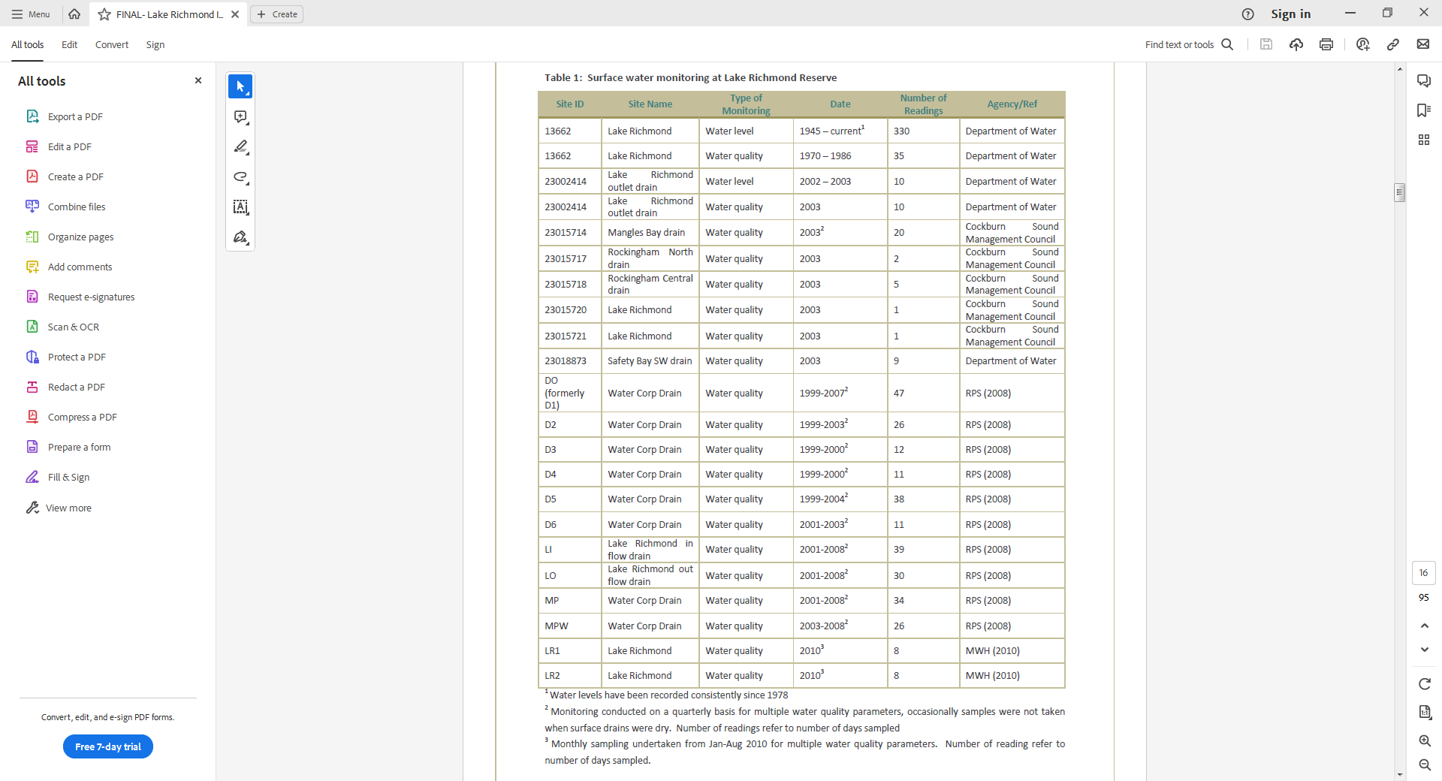**00046956_CoR_SW REP01_Lake Richmond v2.0-Final_compressed.pdf**

Page 6 - On-going bi-annual monitoring (March and October) to continue monitoring analyte trends and the general health of Lake Richmond.

Comment - Although this should come close to catching seasonal minimums and maximums of water level and salinity, dependant on rainfall and other seasonal pattens, biannual isn’t sufficient in terms of understanding the microbialites and their formation status. The convergence of conditions that support thrombolite formation occur in a timeframe measured in days to weeks and the timing of the onset of this will vary from year to year. Hence this will almost certainly be missed by biannual monitoring. Thrombolites monitoring needs to be focussed on specific sites where activity is apparent, not on the lake as a whole. I’d recommend monthly surface water monitoring at minimum. Biannual is possibly sufficient for general aquatic ecology and trends but will limit detailed water and solute balance (modelling) analysis.

Page 8 - two (2) nationally listed Threatened Ecological species (Thrombolites and Sedgelands)

Comment - the data needed for management of these two assets are distinctly different and these two should be assessed separately. My review is focussed on the thrombolites.

Page 9 - The groundwater entering into the Lake is from the Warnbro groundwater subarea. The groundwater is expected to be fresh to marginal.

Comment - There is minimal regional groundwater inflow as evident from the lake’s salinity and the use of the site for stormwater disposal. Most groundwater currently entering the lake is stormwater from earlier in a particular year or from the last few years, which has resided in the aquifer for a brief period. As previously noted, the native groundwater in the area is more saline (i.e. as per MW06)

Page 16 - The adopted site trigger levels indicate dissolved oxygen saturation should be above 90% saturation in freshwater lakes/reservoirs and wetlands. Dissolved oxygen concentrations at eight (8) of the eleven monitoring points within the lake were below this site trigger level. The dissolved oxygen concentrations were above the 90% saturation limit in monitoring points, MP04 and MP05 which are located in the southeast portion of the lake.

Comment - Dissolved oxygen (DO) meters are highly variable (and uncertain) and I don’t think criteria focussed on this parameter are particularly important for the ecosystem’s health with the exception of aquatic fauna if the system became eutrophic. Eutrophic water bodies are those so rich in nutrients that they support an unnaturally dense plant population, the decomposition of which kills animal life by depriving it of oxygen. The DO being highest at the southern end is intuitive as this is the area of the lake where inflow is highest, hence the most turbulent water that will be highest and a source of DO.

Page 16 - The cause of the reduced dissolved oxygen concentrations observed in the March 2015 is unknown

Comment - Could be as simple as due to the use of a different meter or an incorrectly installed DO membrane. As stated above, DO is not particularly relevant.

**Questions Raised by the City of Rockingham in the Scope of Work**

1. *Whether the data outlined in these reports will assist in informing management actions for Lake Richmond or if there are any key water quality data gaps that still need to be investigated;*

Answer: The data outlined and presented in the supplied reports (including other sources know to us and summarised in the table herein) will definitely assist in informing management actions for Lake Richmond. As stated in our previous reports and proposals the data collection has been somewhat ad Hoch from a perspective of thrombolite management having been undertaken with a focus on various aspects of the lake’s hydrology and ecology.

The variable location of data collection sites, the variable data collection frequency (or during some periods a lack of data collection at all) will create some issues during any future modelling analysis. What would have been preferable would have been a consistent monitoring program with surface/groundwater levels/chemistry collected at the same sites at the same frequency through time, which is obviously not available. The available data set is most suited for assessment for impacts to the general aquatic ecology of the lake while the thrombolites require targeted assessment including for management intervention.

Our recent study (Vogwill and Whitehead, 2022) has indicated that the abiotic elements required for thrombolite formation are still present in the lake and we have, through mat experimentation, shown that:

(i) thrombolite forming microbial mats will respond positively to increased lake water salinity;

(ii) reversal of the dominant surface water-groundwater interaction pattern is required to deliver sulfur to the microbial mats appropriately for thrombolite formation; and

(iii) thrombolite accretion (or growth) is still possible if the right habitat conditions are restored.

To recover thrombolite growth to pre-1968 levels, the hydrology of the lake including, the inlet/outlet controls and stormwater inflows/outflows will however need to substantially change. This will allow the lake’s TDS to increase to pre stormwater levels and the surface water groundwater interaction regime to return to a predominantly groundwater discharge features as opposed to the groundwater recharge feature that the lake currently is.

1. *What additional studies or investigations (if any) would be required to:* 
   1. *Understand the impacts of stormwater inflow into Lake Richmond, and*
   2. *Inform (with a high degree of confidence) the predicted benefits of available management/ intervention measures.*

Answer (a): The impact of the fresh, nutrient rich stormwater inflows are qualitatively well understood, i.e. increased nutrient inflow, reduced hydroperiod and reduced TDS has changed the ecological character of the lake. This has made the lake a more suitable habitat for some biotic elements (freshwater macroinvertebrates and fish for example) while making it less suitable for microbial mats that form the thrombolites.

Answer (b): What is now required is a quantitative understanding, via a to be developed tool (i.e. a numerical model of water volumes and water quality) that can be used to look at the degree of change required in the stormwater system and inlet/outlet controls to revert the lake’s hydrology sufficiently to facilitate thrombolite formation at pre-1968 levels. The model will need to include the stormwater catchment but this element can be a represented relatively simply at this stage. The model of the lake will need to be detailed and will need to include surface water groundwater interaction at a high resolution.

A model commensurate with the description above will be able to be constructed with the available data, however until said model is constructed it’s hard to be precise about accuracy (and by extension how much confidence we have in) the model. This is due to the temporally and spatially variable nature of available data as described above. However, modelling is a useful way to consolidate all available data (which is definitely required), to extrapolate the existing data and determine the additional data that will provide the most utility in improving the model’s accuracy/confidence. Regardless a first stage of thrombolite management focused modelling should at least be able to provide our first quantitative understanding of the degree of hydrologic change required, to provide a first pass at feasibility of management intervention. Such a model should also be able to give an indication of the timeframes required for the lake’s hydrology and microbial ecology to recover, noting that this will not be an instantaneous reversion in the lake’s hydrology.

1. *Any other comments or recommendations that you think would support the project.*

Regular ongoing monitoring of surface water and groundwater is preferable as DWER has stopped their routine monitoring in 2010. Also, there are numerous reports and sources of data that need to be consolidated, it’s unclear what the City has available in this context. The first step in any modelling exercise should be a review of all previous work and a consolidation of all data regarding:

(i) the stormwater system feeding into the lake;

(ii) lake hydrology and hydrogeology (including water quality); and

(iii) the ecohydrological conditions (in particular the carbonate and sulfur chemistry) in other similar lakes where microbialite formation is occurring. There is also a need to assess the environmental water requirements of the other biotic elements of Lake Richmond that could be negatively impacted by the proposed management intervention so any trade-offs can be assessed. We have made some initial assessments of this in our 2022 report but more work on this is required.